Retail management application using salesforce

Introduction

Overview **:**

Salesforce can be used to manage orders from retail stores and distributors, including tracking orders, processing payments, and managing inventory levels. This can help field sales teams ensure that orders are fulfilled quickly and accurately and that inventory levels are maintained at optimal levels.

Purpose:

A retail management system (RMS) is a platform that combines several modules to aid in the day-to-day operation of a retail store or chain, such as managing and buying inventory, checking out customers, scheduling employee shifts, keeping track of finances, etc

Problem definition & Design Thinking

**Empathy map:**

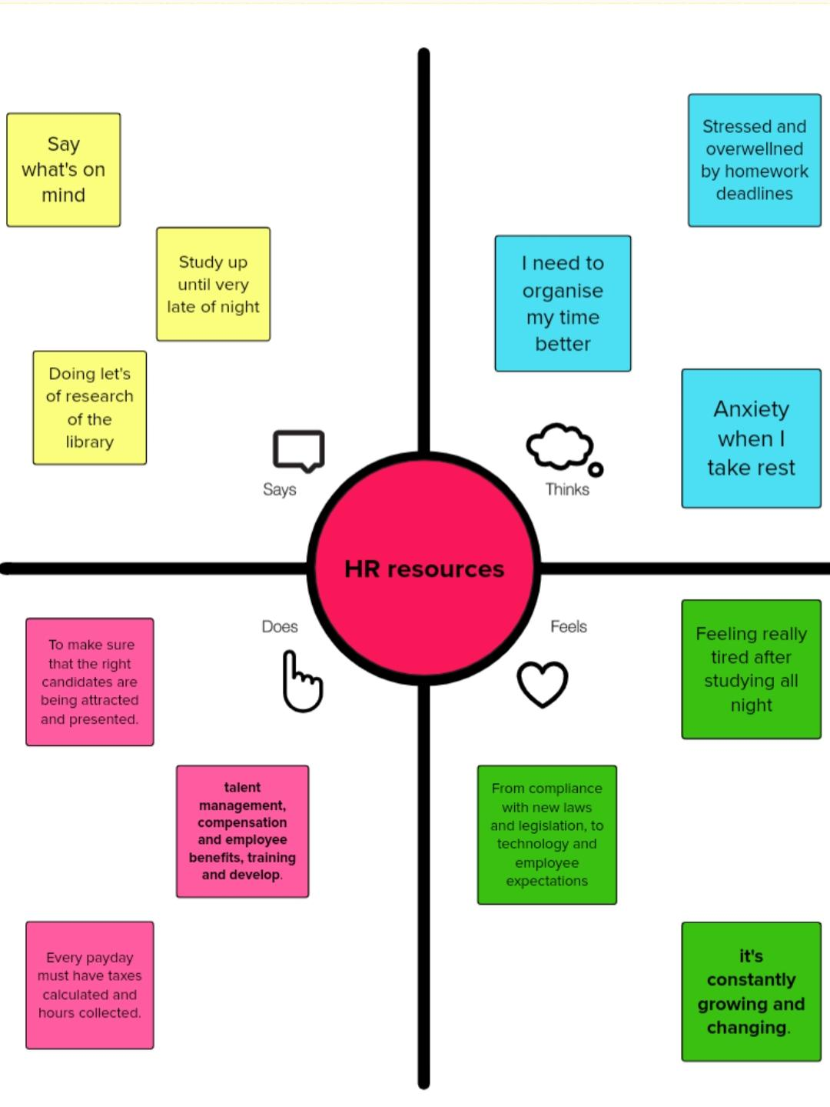

**Ideation and brainstorming map:**

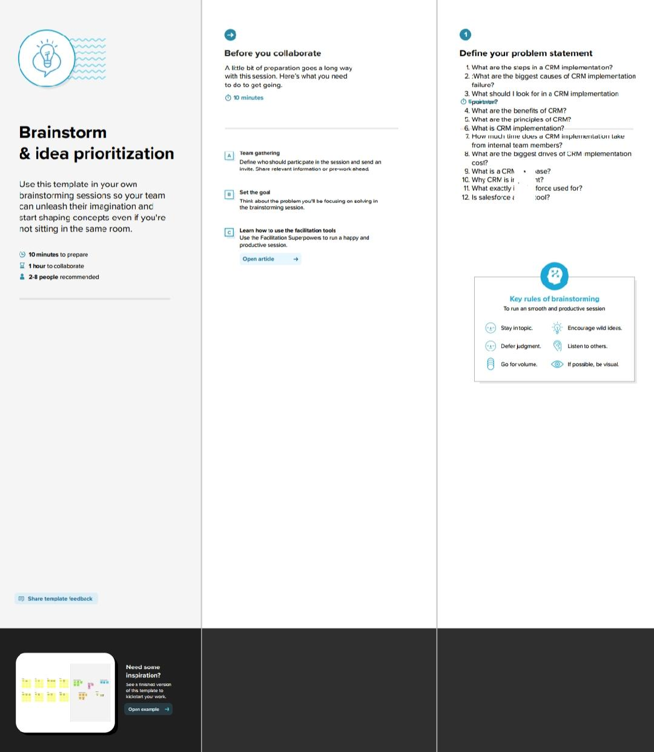

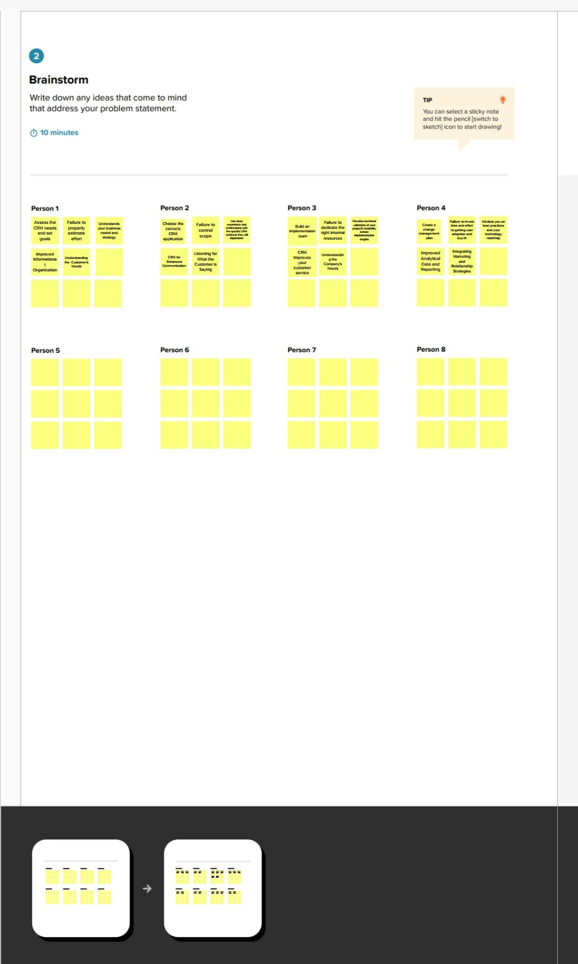

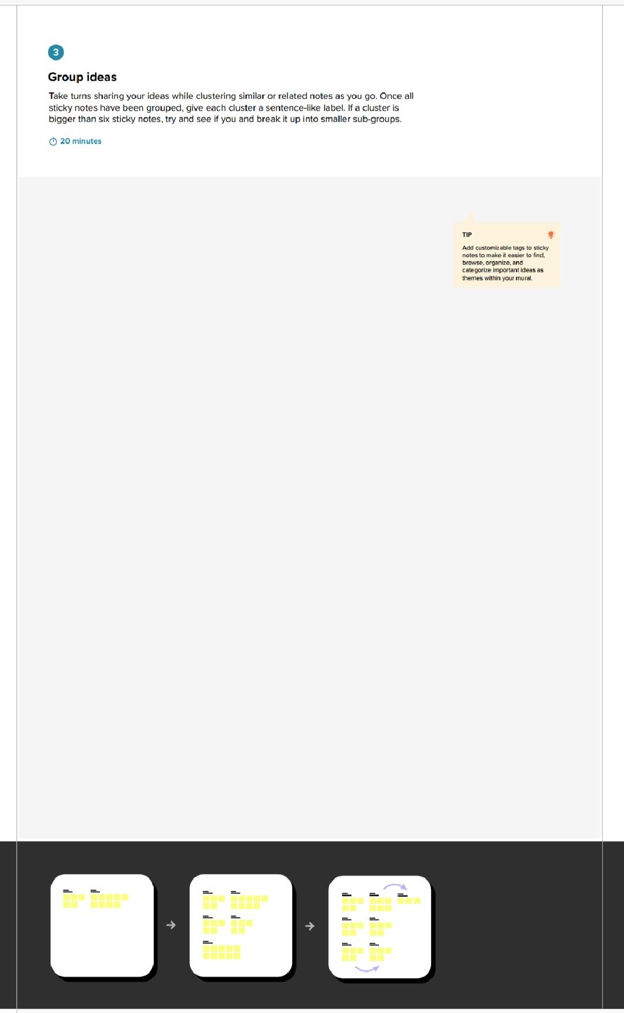

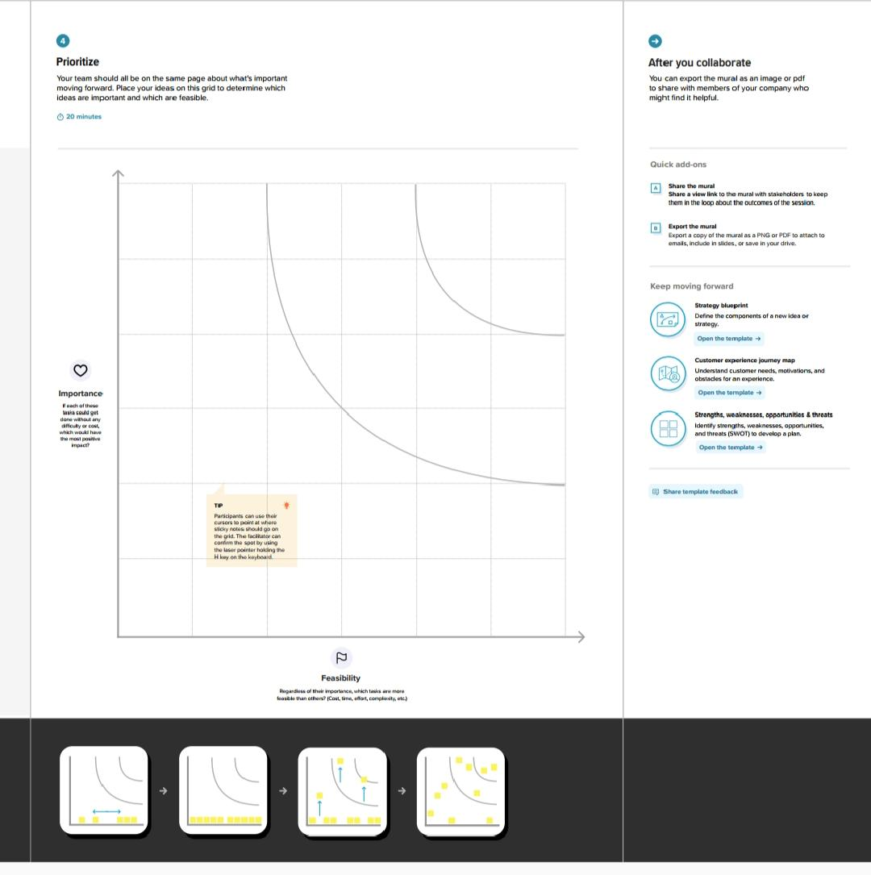**RESULT**

**Data model:**

|  |  |  |
| --- | --- | --- |
| Objects | Fields | Data type |
| Account | Account name | Text |
| Order | Account | Master-detail |
| Phone | Contact | Master-detail |
| Dispatch &tracking | * Despatched * Sales order * Tracking id * Expectation date of delivery | Checkbox |
| Campaign |  | Text |
| Warehouse |  | Look up |
| Leads |  | Text |
| Opportunity | Opportunity_c | Checkbox |
| Contact | Account website | Formula |

**Activity & screenshot**

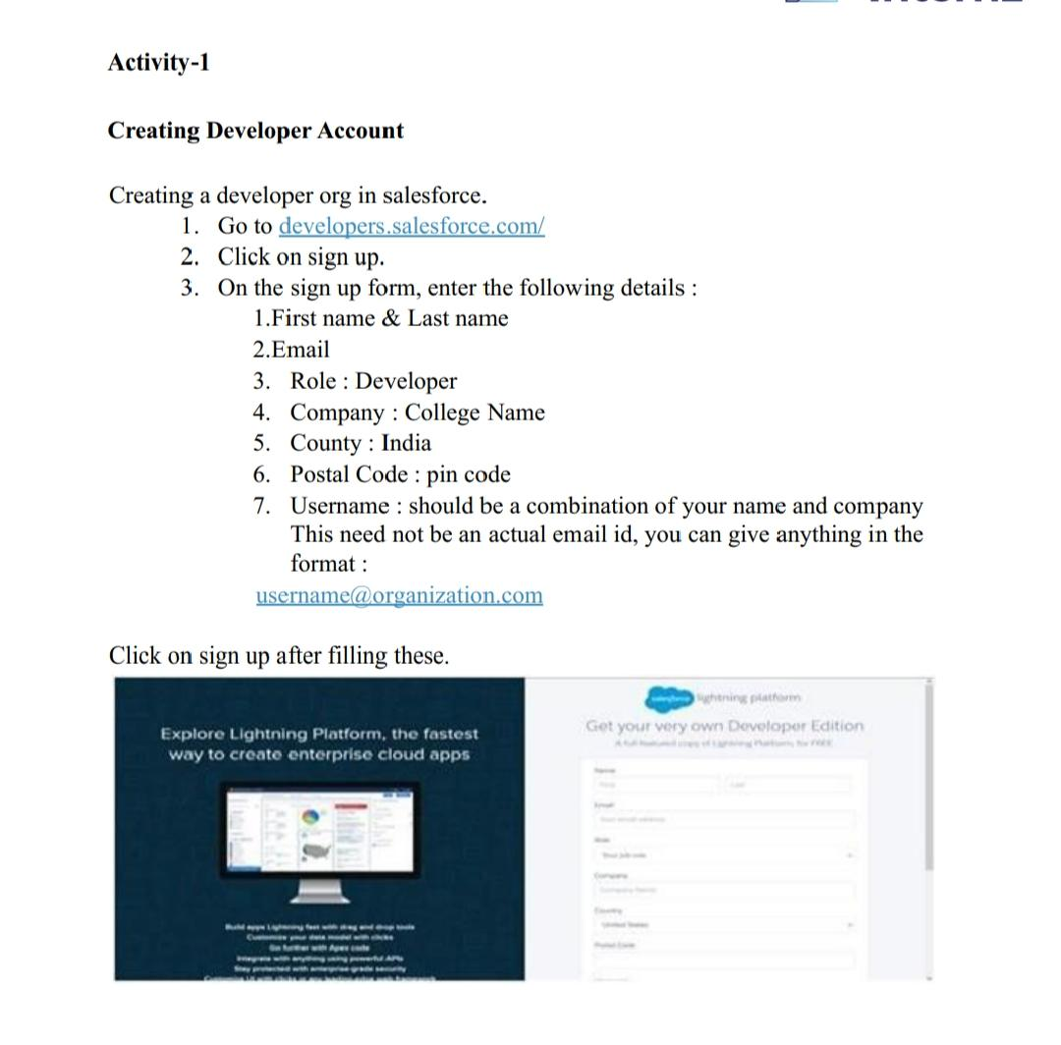

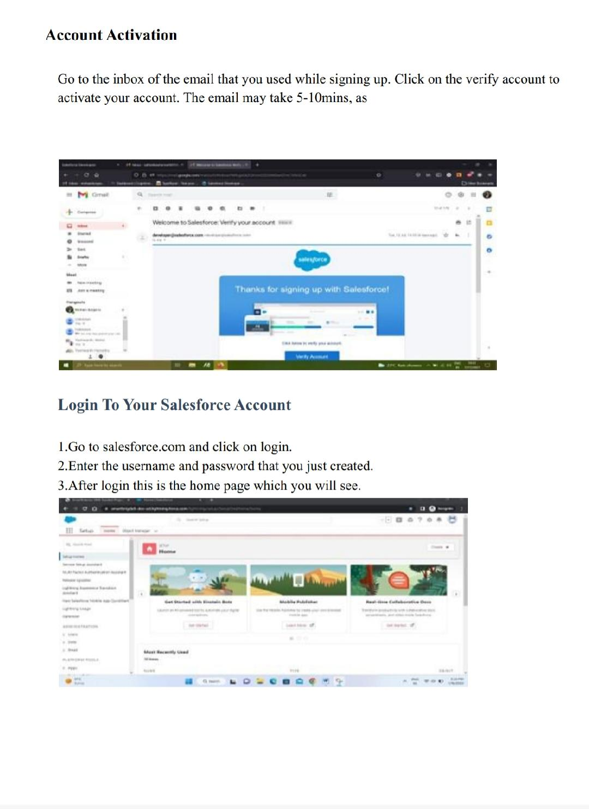

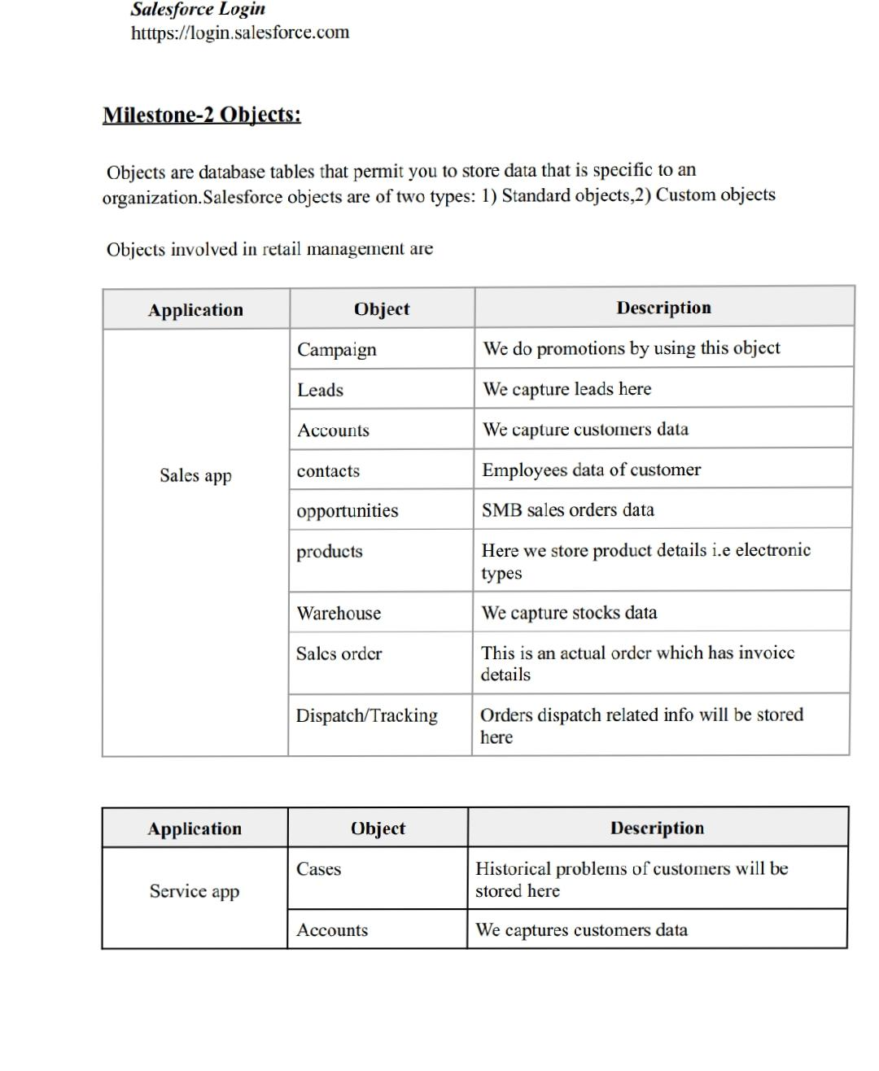

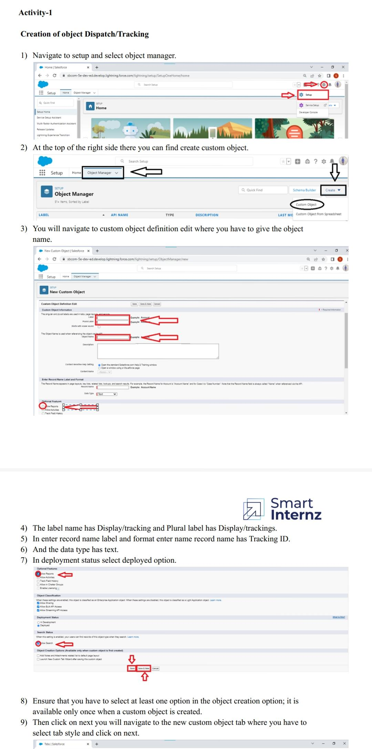

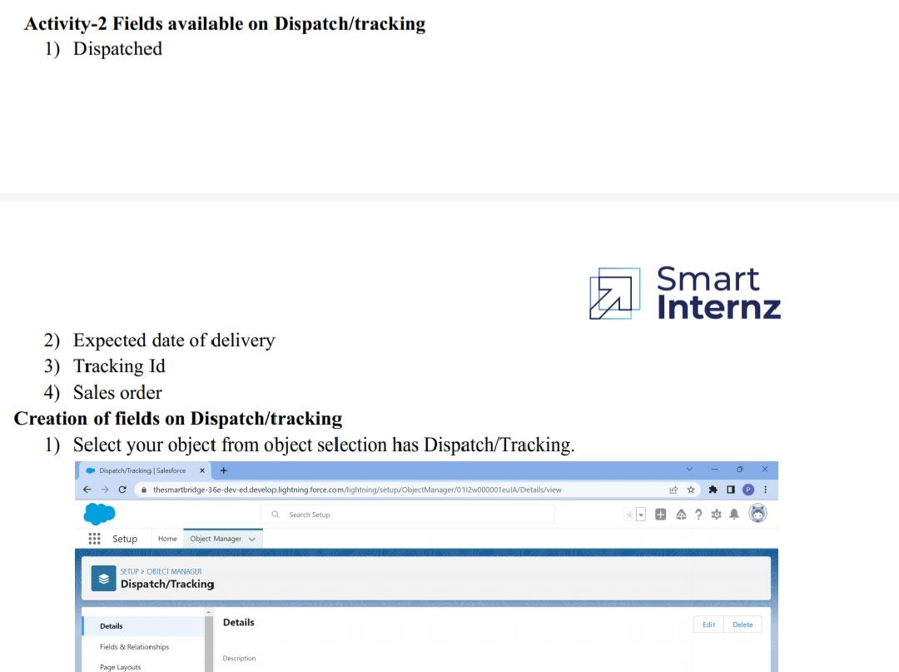

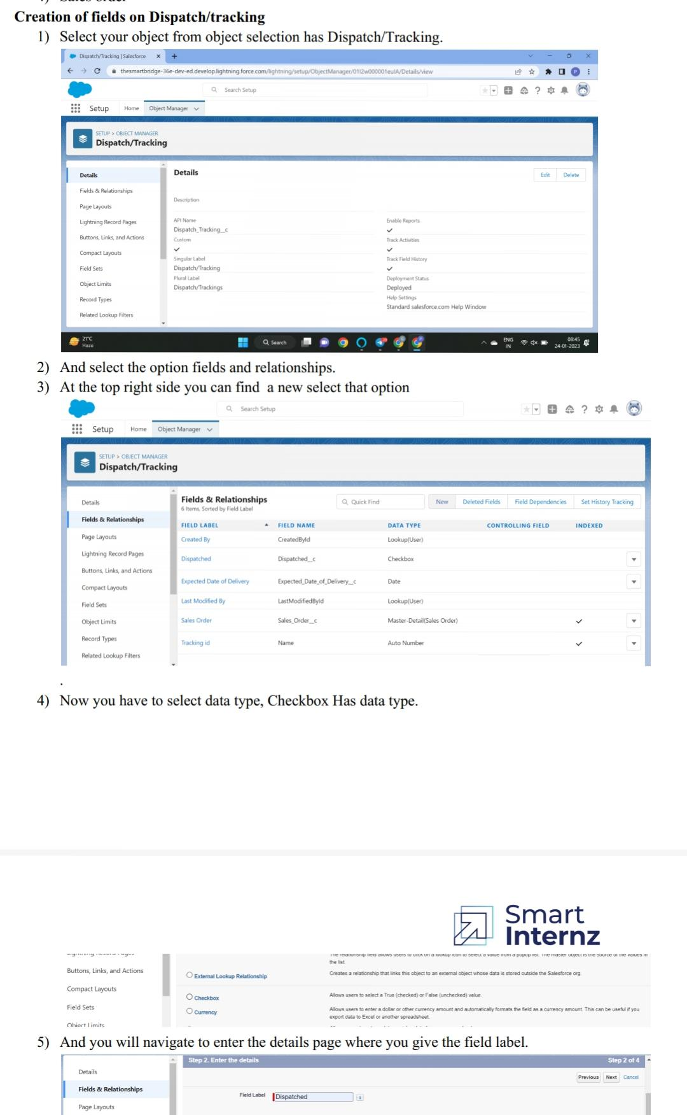

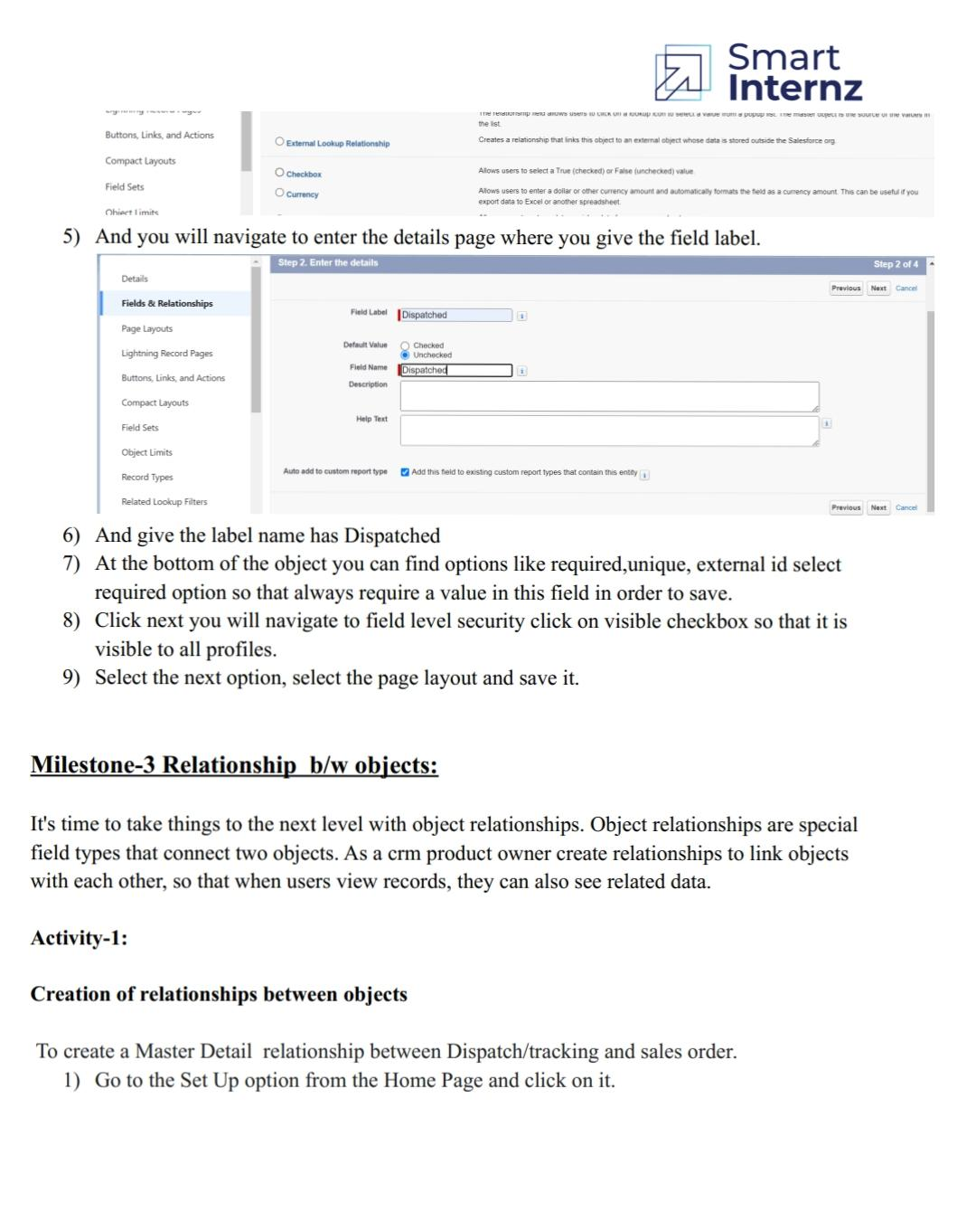

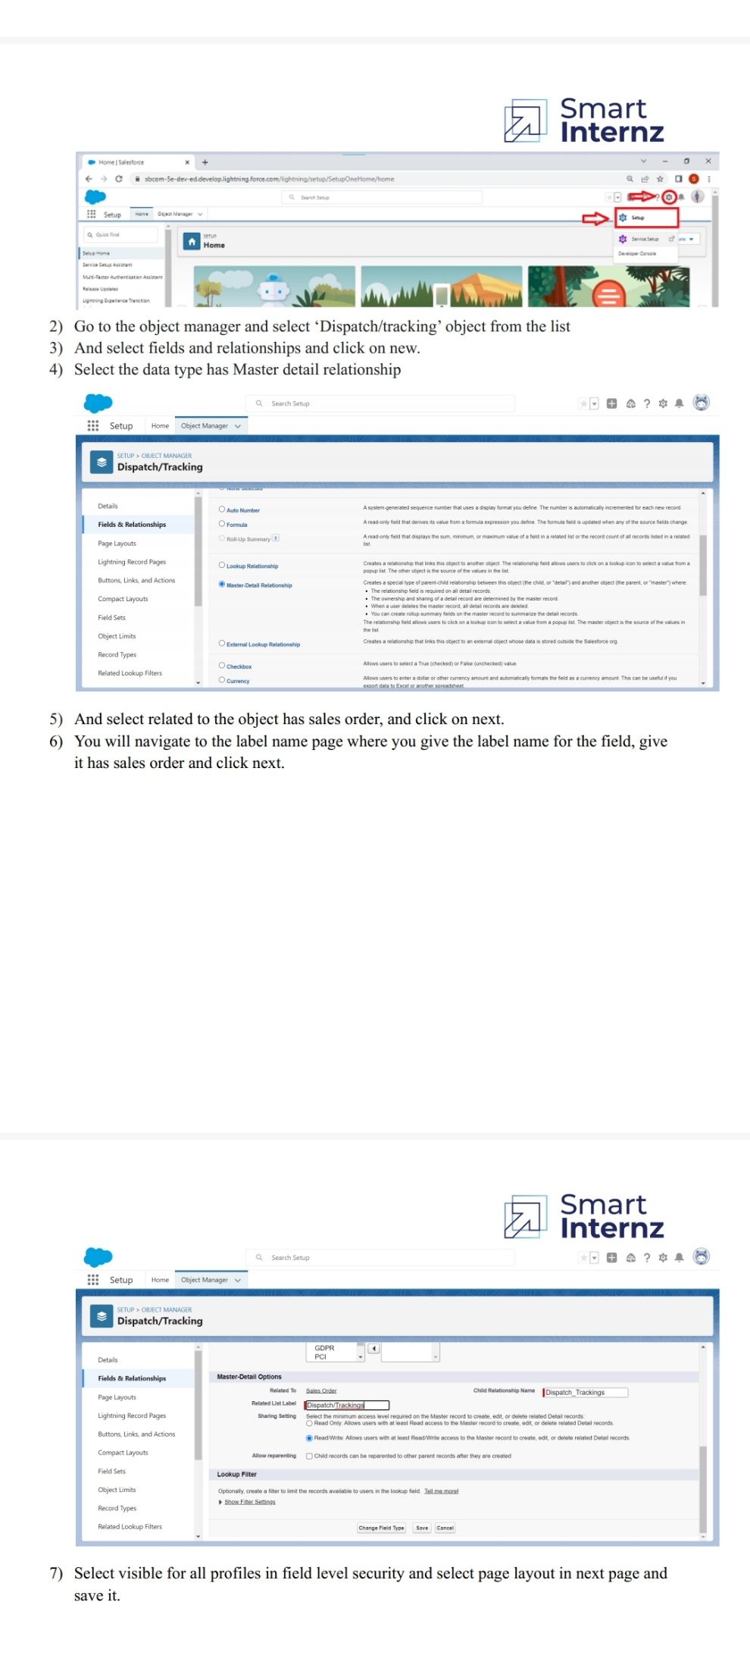

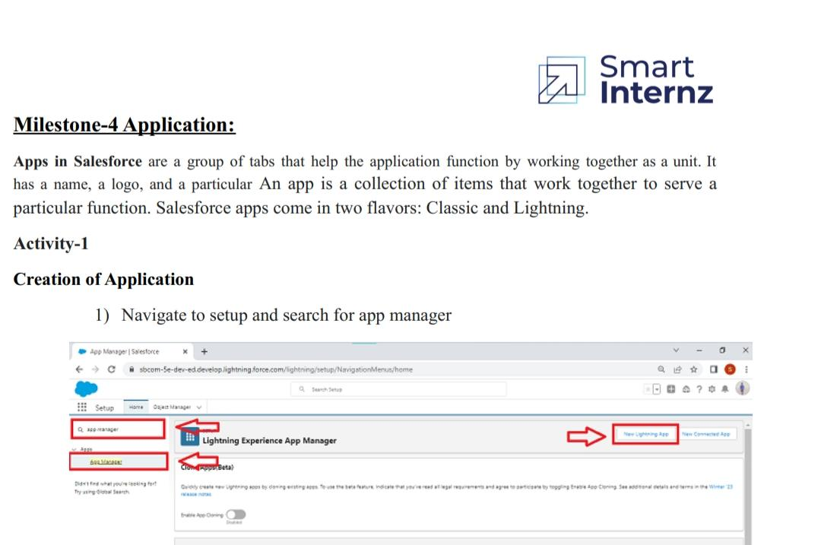

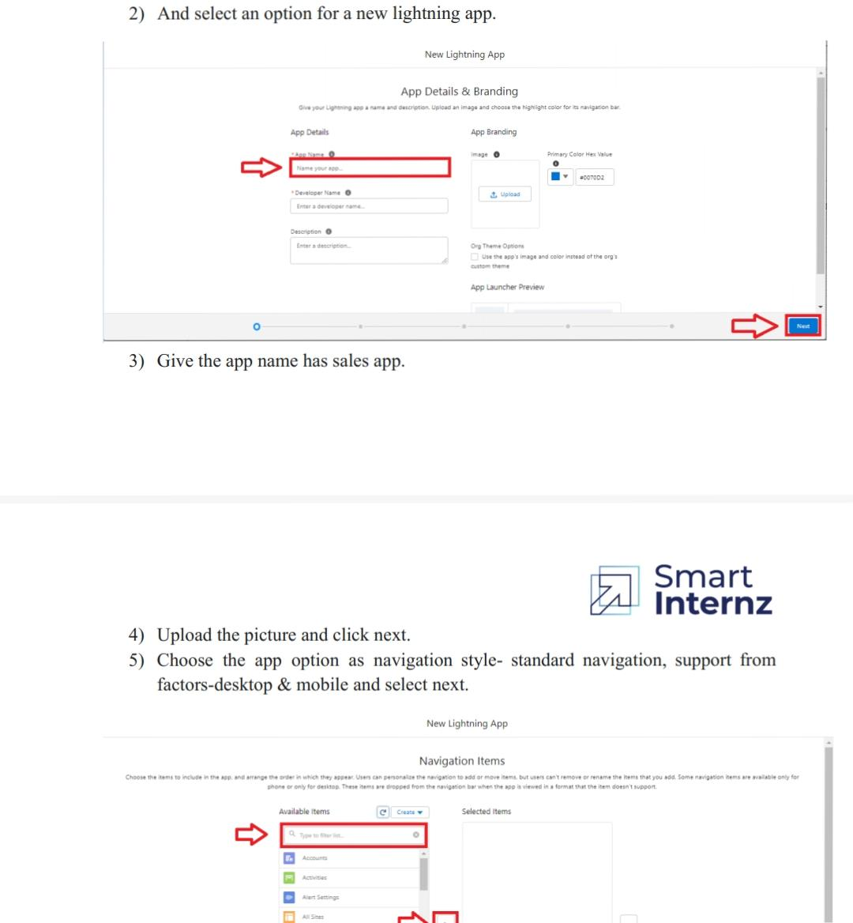

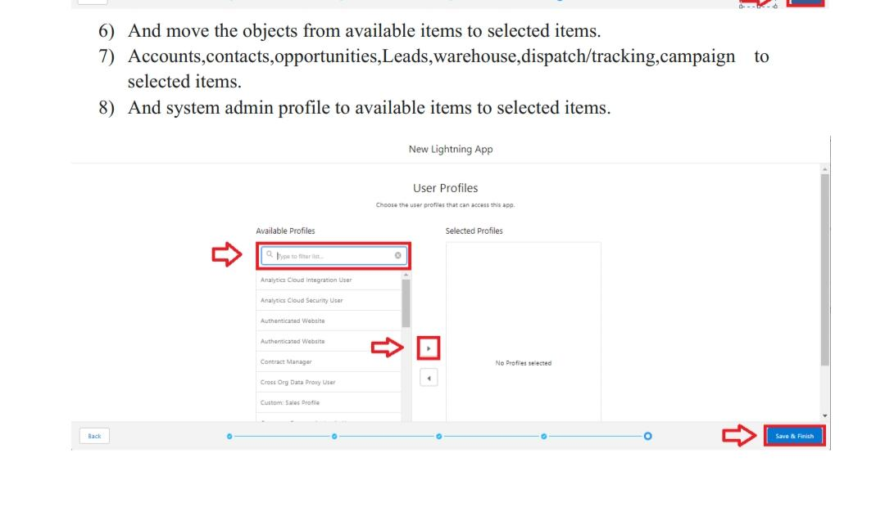

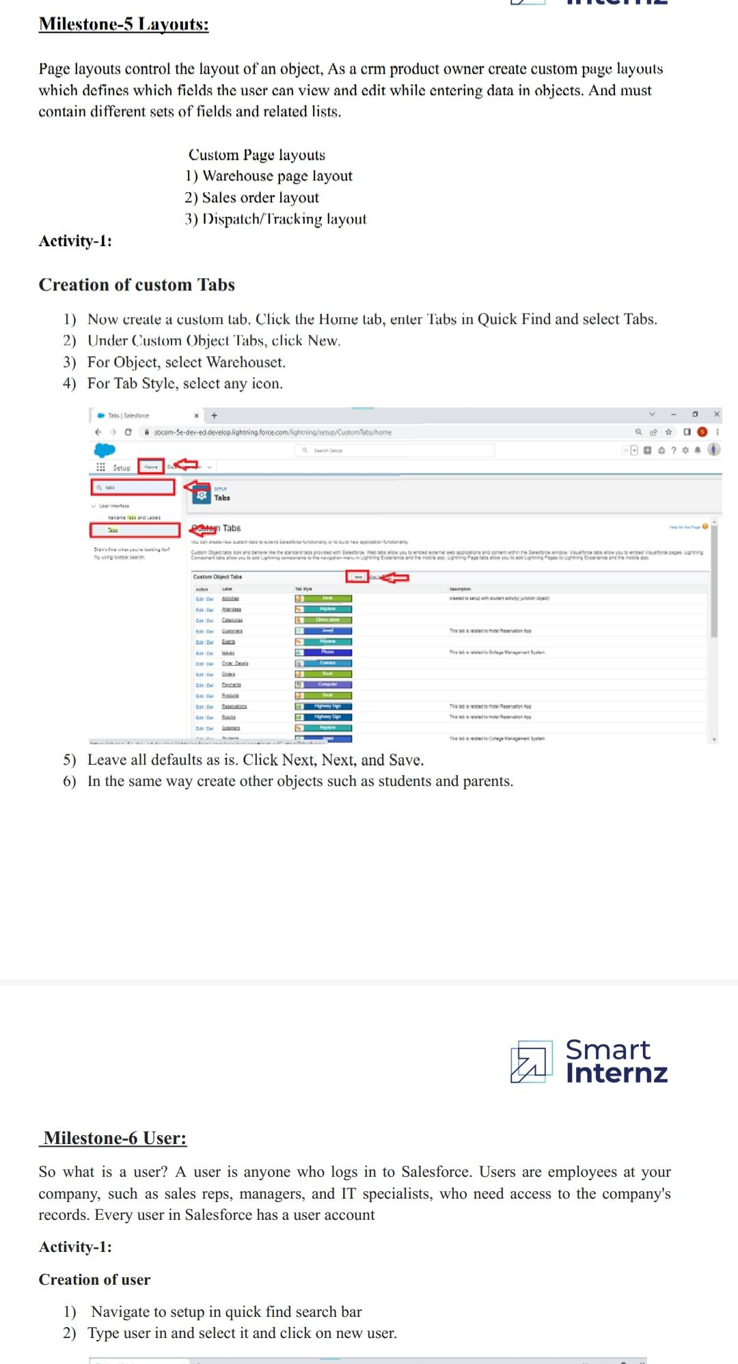

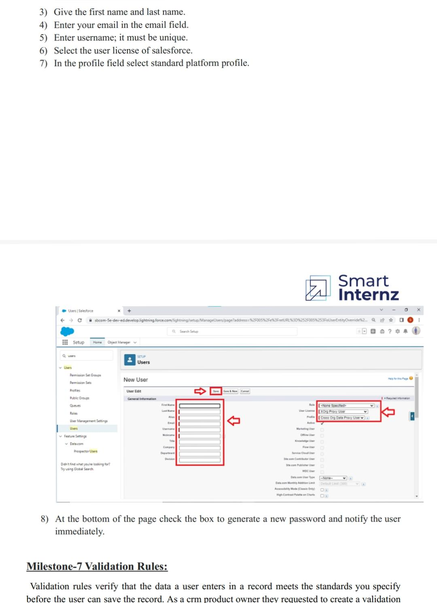

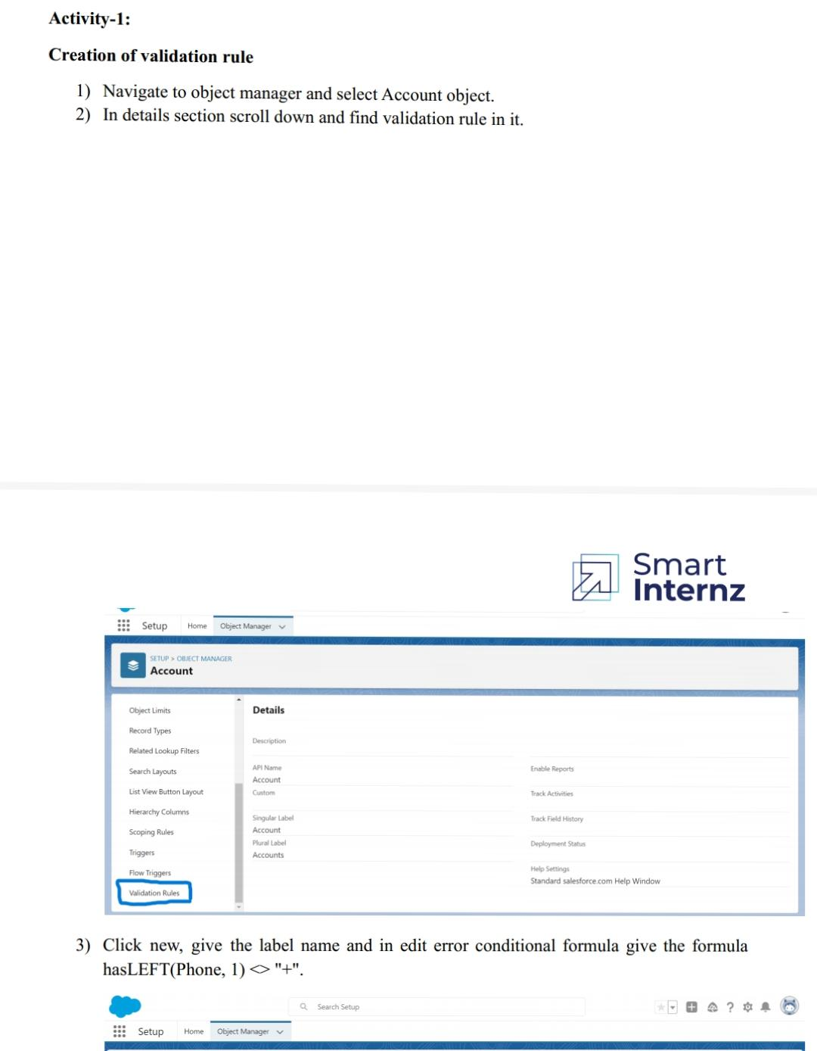

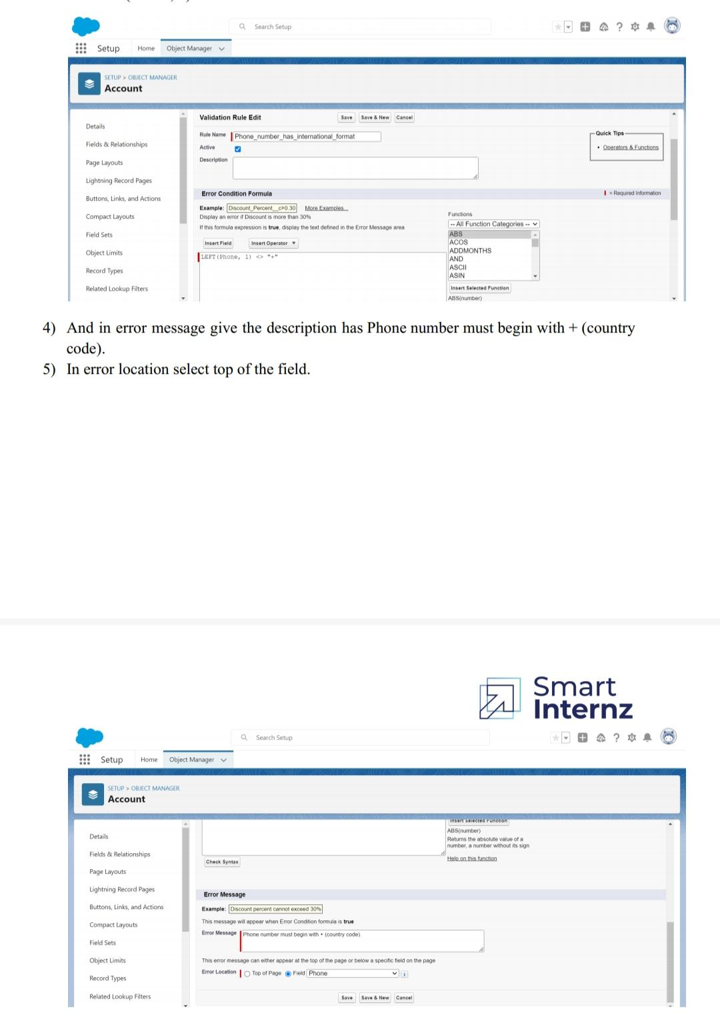

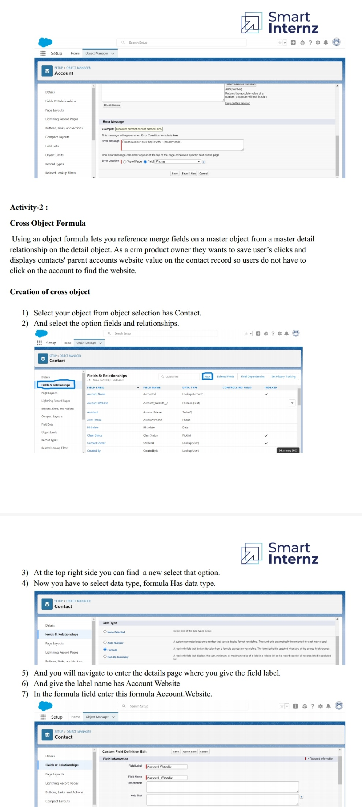

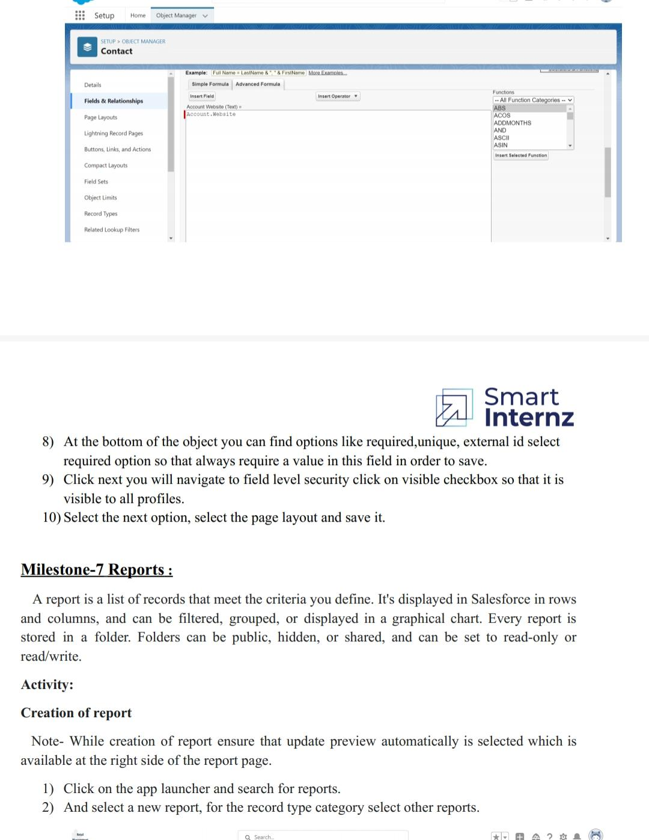

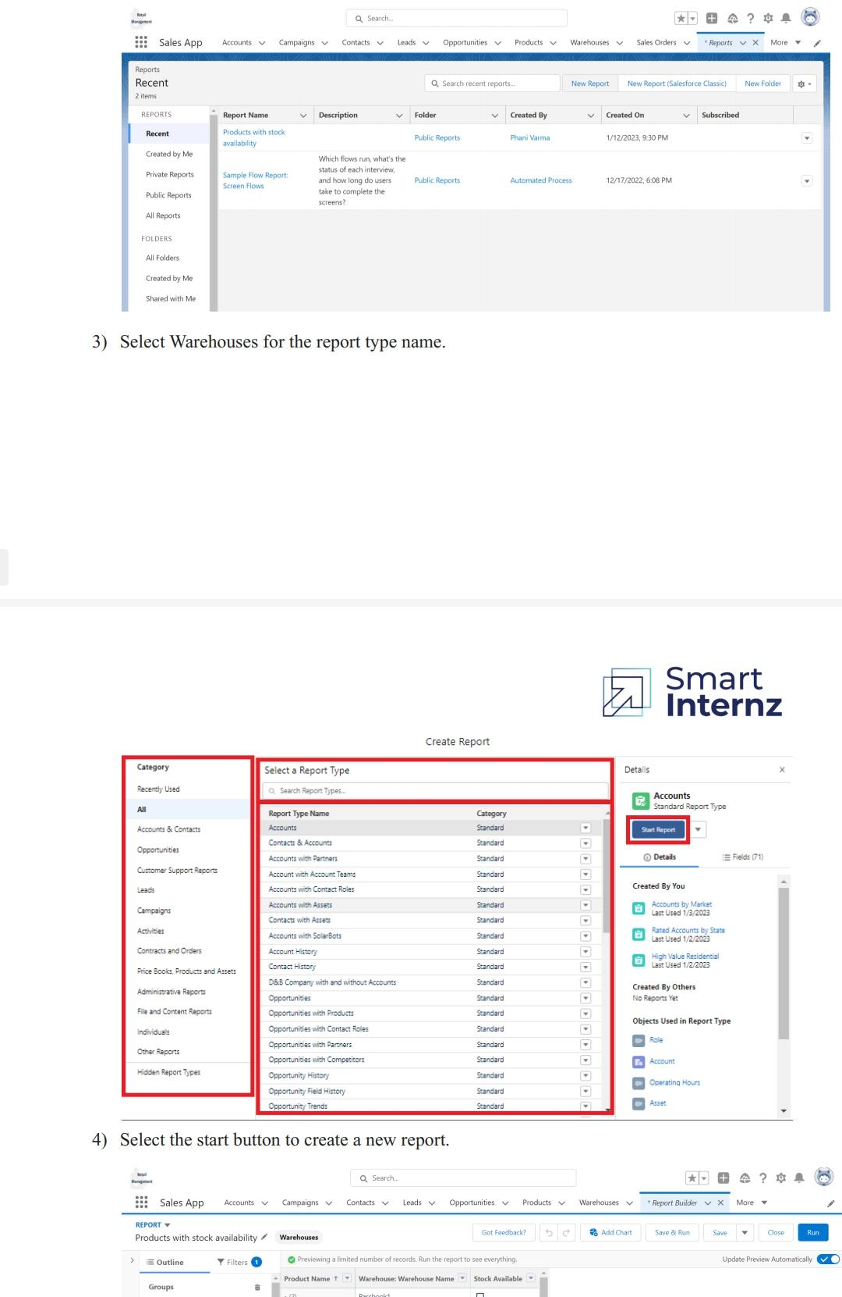

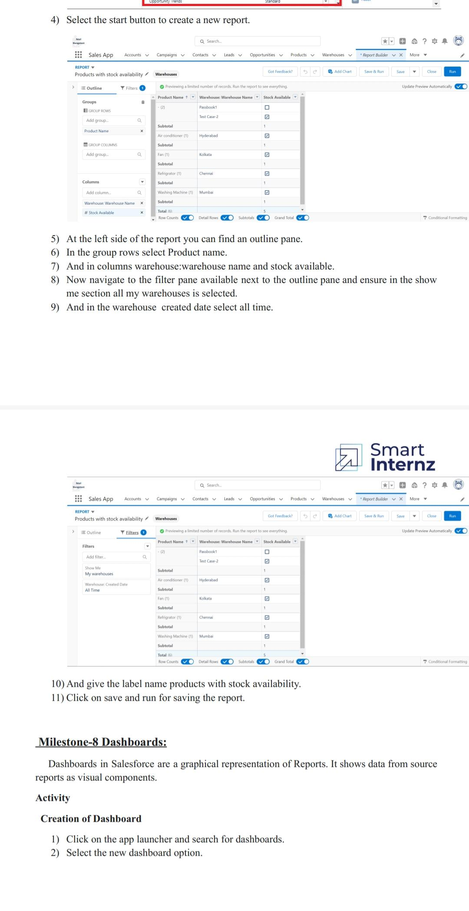

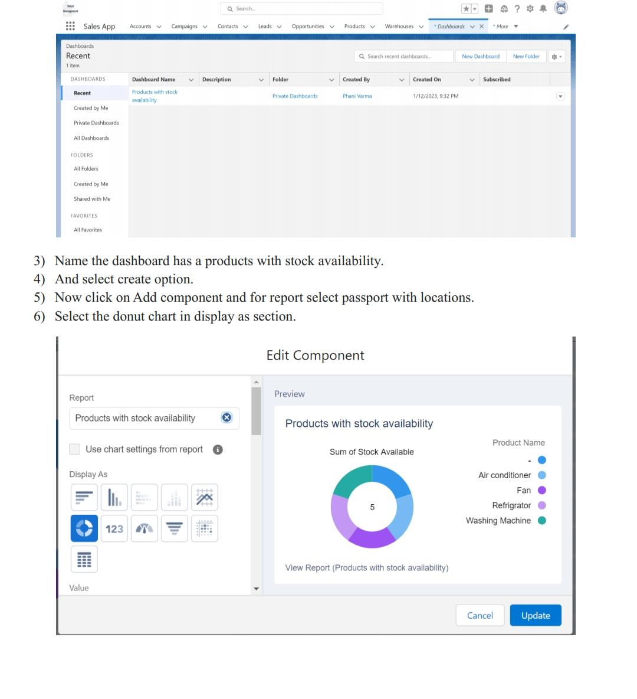

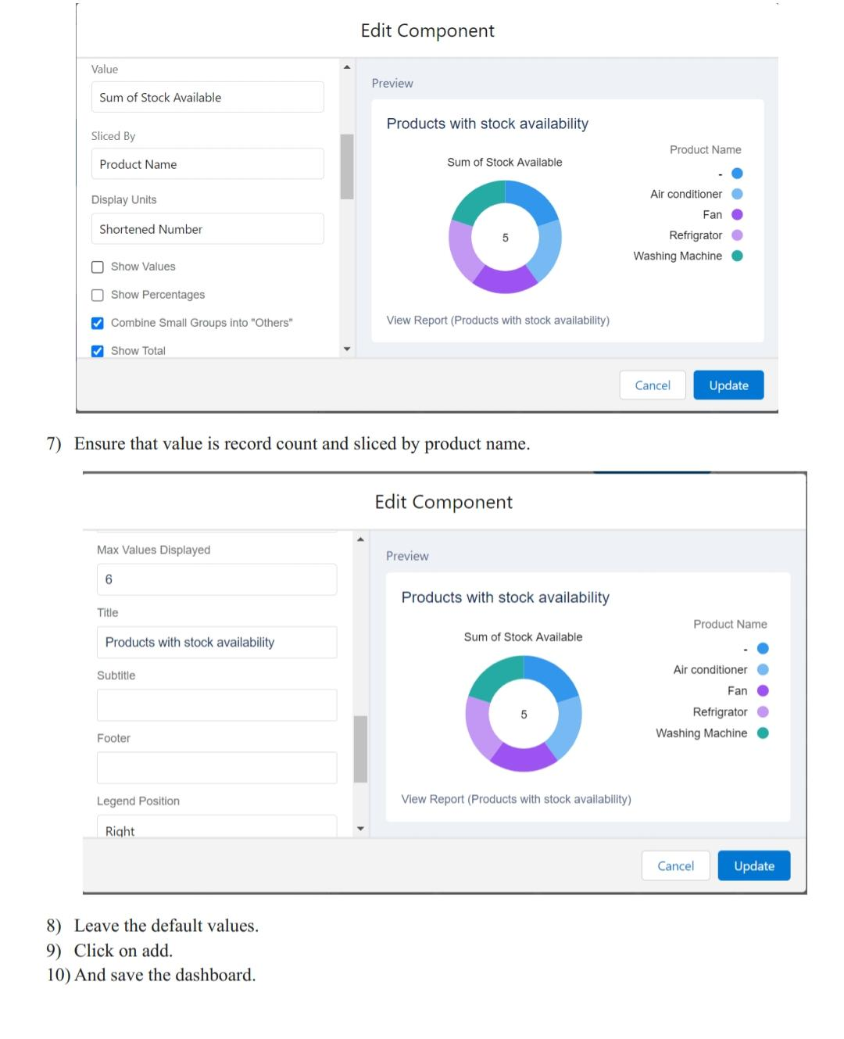

**Trailhead profile public URL**

Team leader :<https://trailblazer.me/id/dhanush93>

Team member 1 :<https://trailblazer.me/id/trailblazer1mothi>

Team member 2 :<https://trailblazer.me/id/pparthiban9>

Team member 3 :<https://trailblazer.me/id/karthi71>

Advantage & Disadvantage

Advantage:

* Customer Engagement: Salesforce provides a unified platform for managing customer interactions, which enables retailers to deliver personalized shopping experiences. With features like Einstein AI and Live Agent, retailers can provide real-time assistance and support to customers, resulting in increased customer loyalty.

* **Data Management: Salesforce provides a centralized repository for managing customer, product, and sales data. Retailers can easily access and analyze this data to make informed business decisions, such as optimizing pricing and product placement.**

**Disadvantage:**

* **Expensive.**
* **You have to pay for add-ons to get the most out of the software.**
* **Configuration and setup is complex and time-consuming.**
* **Cluttered interface makes navigation and simple tasks unnecessarily complex.**
* **The learning curve never seems to end.**
* **Customer support has a poor reputation**

**Applications**

* **Salesforce can be used to create and manage beat plans for field sales teams. This includes scheduling store visits and tracking the results of those visits.**
* **Salesforce for retail can also be used to track the performance of field sales teams, including metrics such as sales and customer satisfaction.**
* **Salesforce for Retail is a set of solutions built on the Salesforce platform designed to help retail companies manage their operations and customer relationships.**
* **These solutions include tools for managing inventory, sales, customer data, marketing, and more.**

**Conclusion**

1. **Whether you have a small shop for a big store, if you are running a retail business, then retail management is must to run it efficiently.**
2. **Either you are a seller or a customer, everybody has 24 hours in a day and the time is very important for all.**
3. **Retail management optimizes internal processes such as inventory management, offline and online storefronts, warehouse operations, payment and accounting, and human resources.**
4. **Retail management improves overall company cohesion. Retail store management improves customer experience and boosts customer satisfaction.**

**Future scope**

* **The career opportunities are in the areas of Store Operations, Retail Marketing, Visual Merchandising, Buying & Merchandising, Brand Management, Store Location & Design, MIS in Retail, Human Resource Management, E-Tailing and Digital Retailing.**
* **India’s retail industry is expected to be worth US$ 883 billion in 2020, of which US$ 608 billion would be spent on groceries, according to Forrester Research. By 2024, it is expected that the market will increase to US$ 1.3 trillion.**
* **Retail Management courses impart knowledge in fields like Marketing, Finance, Supply Chain Management, and Strategic Management.**
* **Further, these programs also equip students with the necessary skills to manage and run stores. (Viagra) Thus, a degree in this field can provide a multitude of career opportunities.**